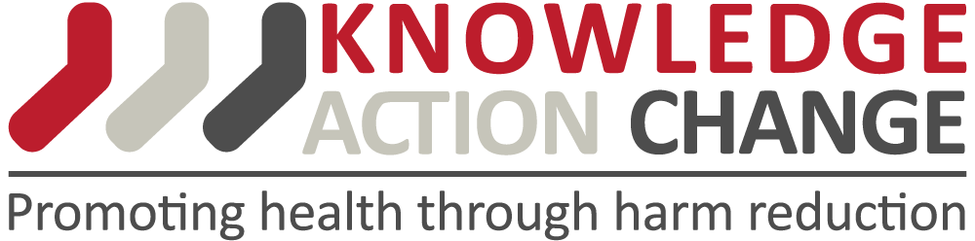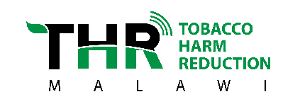
PRESS RELEASE
Embargoed until 00:01hrs, 2nd November 2020
Launch of ‘Burning Issues: The Global State of Tobacco Harm Reduction 2020’
Lilongwe — On 4th November, 2020, the Tobacco Harm Reduction Malawi project in conjunction with a UK-based public health agency, Knowledge•Action•Change (K•A•C), are launching K•A•C’s report, Burning Issues: The Global State of Tobacco Harm Reduction 2020.
Burning Issues is the second edition in a biennial series from the Global State of Tobacco Harm Reduction project, which maps the global, regional and national availability of safer nicotine products, the regulatory responses and public health potential of tobacco harm reduction. The report argues that the public health principle of harm reduction can play a major role in ending tobacco smoking and upholding public health.
Harm reduction refers to public health interventions that focus on providing people with less risky options. Harm reduction acknowledges that some people find it extremely difficult or impossible to give up smoking. People smoke for the nicotine but are made ill or die from the toxic chemical substances in tobacco smoke such as tar. Therefore, tobacco harm reduction offers smokers an opportunity to consume nicotine in less harmful ways. Some of the safer nicotine products and innovations include electronic cigarettes (vapes), heat-not-burn devices and pasteurized snus.
Burning Issues addresses both progress and achievements in the field since the first edition was published in 2018, but also identifies the major obstacles preventing tobacco harm reduction from fulfilling its public health potential worldwide. With over 8 million deaths still attributable to smoking-related causes every year, the majority of which are in low- and middle-income countries, the report authors hope that the findings, conclusions and recommendations will be of interest to policymakers at all levels around the world.
Due to COVID-19 and restrictions per gathering, the public is invited to participate virtually. Registration is free and can be accessed at this link https://events.gsthr.org

For enquiries and arranging press accreditation for the event, send an email to chimwemwengoma14@gmail.com or call 0882 93 72 76
Notes to editors:
Venue: BICC, Umodzi Park,
Date: 4th November, 2020.
Time: 12:00 noon – 5:00 PM

